Survey Analysis of Student Satisfaction in Online Learning

Eliana Alon | Lauren Furman | Joseph Aytch | Michelle Valencia

DSC 450 Applied Data Science

Bellevue University- Fall 2024

Table of Contents

Introduction 2

Business Problem/Hypothesis 2

Methods/Analysis 2

HOW STUDENTS ARE ADAPTING TO ONLINE LEARNING 2

Adaptability vs. IT Students 3

Adaptivity by level of education 4

Institution type and the level of adaptivity 5

Results 7

Recommendations/Ethical Considerations 8

Conclusion 9

References 9

Appendix 9

# Introduction

As time passes, more students have shifted to online learning. This change has brought about its own set of advantages and disadvantages as students around the world navigate this new environment. This study explores the factors that influence student adaptability to this new educational landscape, with a particular focus on demographic factors and access to technology. Through a survey of 1,205 participants, we delved into the complexities of online learning, seeking to understand how students from diverse backgrounds and varying levels of technological proficiency navigate this digital frontier.

Using a combination of exploratory data analysis and machine learning (particularly multiple linear regression), our analysis considers a range of factors, including gender, education level, institution type, internet connectivity, and financial resources, to paint a comprehensive picture of the online learning experience. By shedding light on the key drivers of adaptability, this study aims to inform educational institutions and policymakers on how to better support students in this evolving educational paradigm.

# Business Problem/Hypothesis

One particular issue stands out from the others: are students adapting or struggling to this new paradigm? A disconnect caused by difficulties with online learning would pose a problem for educational institutions as they strive to provide high-quality education and ensure student success in this environment. Therefore, the main problem we are trying to tackle is understanding the key factors that influence student adaptability to online learning and developing targeted interventions to improve the overall online learning experience and outcomes. By addressing this issue, educational institutions can enhance student engagement, retention, and ultimately, their academic success in the digital age.

**Hypothesis:** We hypothesize that the data will reveal a significant struggle and learning curve when it comes to online learning compared to learning in person.

# Methods/Analysis

## HOW STUDENTS ARE ADAPTING TO ONLINE LEARNING

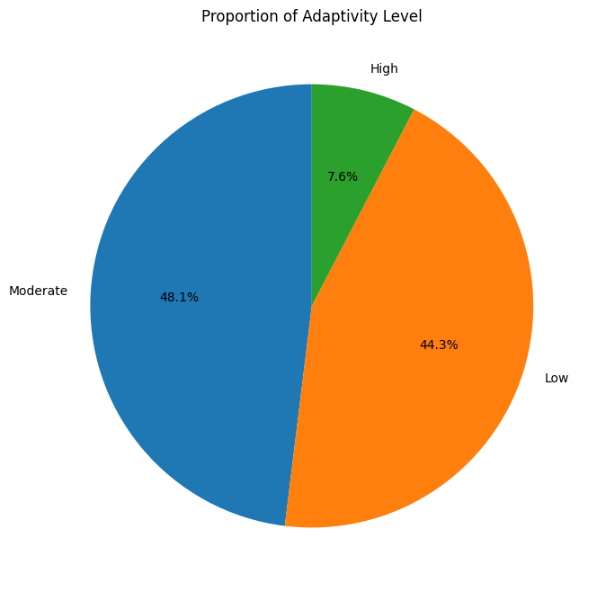

Figure

A survey that contained 1,205 participants, only 7.6% highly adapted to online education. Those who performed moderately were 48.1% and 44.3% performed poorly. You can see that based on the pie chart presented in figure 1.

## Adaptability vs. IT Students

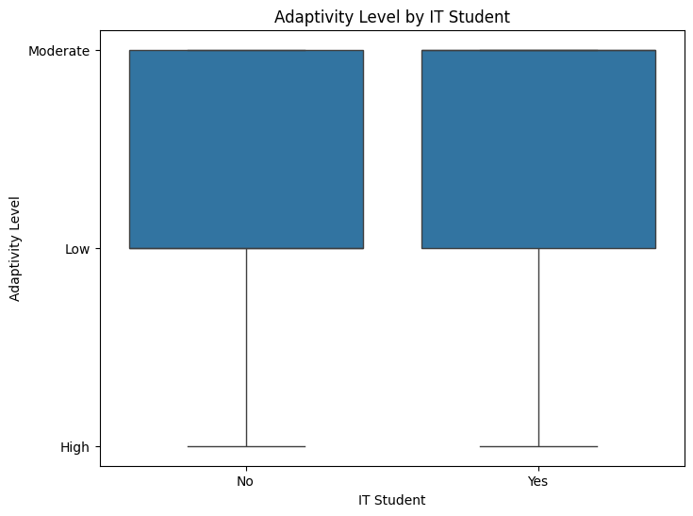

Figure

**IT Student**

**No:** 1.530474

**Yes:** 1.797834

Based on the chart in figure 2 and the correlation above, adaptivity between IT Student and Non-IT Student supports that an IT Student is relatively more (not significant) adaptable to online learning vs. a non-IT student.

## Adaptivity by level of education

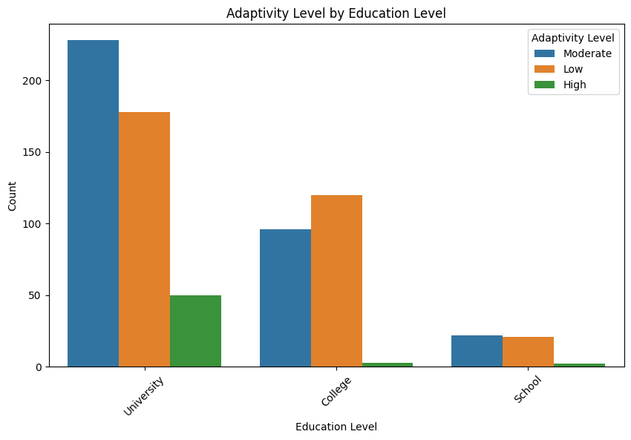

Figure

Based on the bar graph above (figure 3) that breaks down adaptivity level per education level, at a glance the University has the highest rate adaptivity.

## Institution type and the level of adaptivity

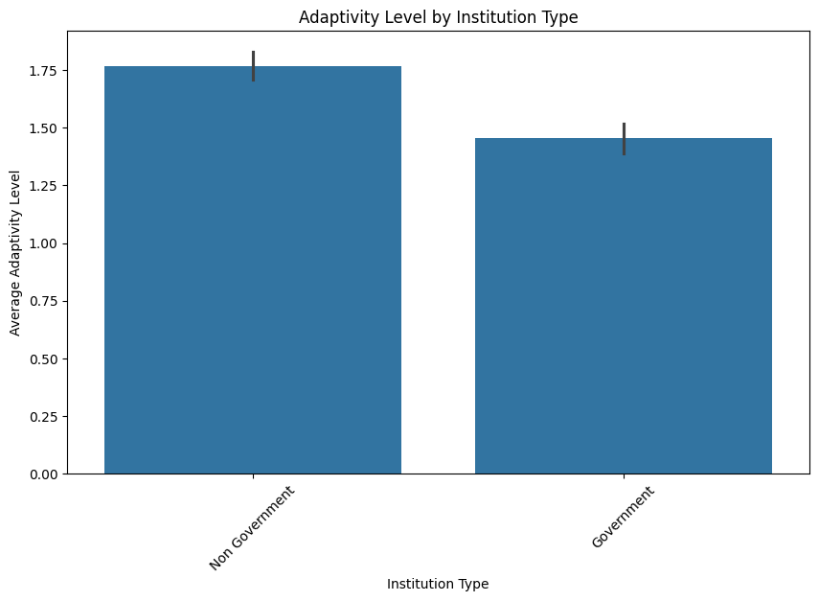

Figure

**Institution Type**

**Government:** 1.454839

**Non-Government:** 1.768293

Per my observation (figure 4), the institution type does support that Non-Government institutions tend to have a higher adaptivity level.

What demographic factors are most strongly associated with adaptivity in online learning?

Coefficients for each variable:

Gender: -0.20575842186607562

Education Level: -0.026660507564430252

Institution Type: 0.20240265465248092

IT Student: -0.03650433320463228

Location: 0.05742767335839569

Load-shedding: 0.05107844474611202

Financial Condition: 0.2512793513790662

Internet Type: -0.00673222484892326

Network Type: 0.22620841467088298

Class Duration: 0.20390933855200652

Self Lms: 0.3066633369196816

Device: -0.09421504261379565

Age: 0.055450973718619775

**Below we have explained the results from the Multiple Linear Regression model:**

**Gender**: Being a specific gender is associated with a decrease of about 0.206 units in the dependent variable, holding all other factors constant.

**Education Level**: A decrease in education level is linked to a decrease of approximately 0.027 units in the dependent variable, indicating a negative impact.

**Institution Type**: Attending a certain type of institution (Government or Non-Government) is associated with an increase of about 0.202 units in the dependent variable, suggesting a positive effect.

**IT Student**: Being an IT student or not is associated with a decrease of about 0.037 units in the dependent variable.

**Location**: This positive coefficient indicates that being in a particular location is associated with an increase of about 0.057 units in the dependent variable.

**Load-shedding**: Interestingly, load-shedding (power outages) is associated with an increase of about 0.051 units in the dependent variable. This might suggest that it has some counterintuitive or contextual effect that needs further exploration.

**Financial Condition**: A better financial condition is strongly associated with an increase of about .251 units in the dependent variable, indicating that this factor has a significant positive effect.

**Internet Type**: This very small negative coefficient indicates a slight decrease of 0.007 units in the dependent variable associated with a specific type of internet connection.

**Network Type**: This suggests that using a certain type of network is associated with an increase of about 0.226 units in the dependent variable.

**Class Duration**: Longer class durations are associated with an increase of approximately 0.204 units in the dependent variable.

**Self Lms**: This coefficient indicates a strong positive relationship, suggesting that self-directed learning management systems (Self LMS) are associated with an increase of about 0.307 units in the dependent variable.

**Device**: The type of device used is associated with a decrease of about 0.094 units in the dependent variable, indicating a negative impact.

**Age**: An increase in age is associated with an increase of approximately 0.055 units in the dependent variable.

** In summary, these coefficients show correlation, not causation. They indicate relationships but do not confirm that changes in the independent variables cause changes in the dependent variable.

# Results

***Adaptation Levels***

**Overall Adaptation**: Out of 1,205 participants, only 7.6% highly adapted to online education, 48.1% performed moderately, and 44.3% performed poorly. This indicates a significant challenge in adapting to online learning for the majority of students.

***IT Students vs. Non-IT Students***

**Comparison**: IT students had a slightly higher adaptability score (1.798) compared to non-IT students (1.530). Although the difference is not statistically significant, it suggests that IT students might have a slight edge in adapting to online learning environments.

***Education Level***

**University Students**: The bar graph analysis shows that university students have the highest adaptability rates compared to other education levels. This could be due to their higher exposure to technology and self-directed learning.

***Institution Type***

**Government vs. Non-Government**: Students from non-government institutions had higher adaptability scores (1.768) compared to those from government institutions (1.455). This suggests that non-government institutions might provide better resources or support for online learning.

***Demographic Factors***

**Multiple Linear Regression Analysis**: The coefficients indicate the strength and direction of the relationship between each demographic factor and adaptability. For example, financial condition (0.251) and self-directed learning management systems (0.307) have strong positive associations with adaptability, while gender (-0.206) and device type (-0.094) have negative associations.

# Recommendations/Ethical Considerations

***Improving Adaptability***

**Targeted Support**: Provide additional resources and support for non-IT students and those from government institutions to improve their adaptability to online learning.

**Technology Access**: Ensure all students have access to reliable internet and appropriate devices. This could involve providing subsidies or loan programs for necessary technology.

***Financial Support***

**Aid Programs**: Implement financial aid programs to assist students in poorer financial conditions, as financial stability is strongly associated with better adaptability.

***Ethical Considerations***

**Privacy and Confidentiality**: Maintain strict confidentiality of student data collected through the survey. Ensure that any interventions are equitable and do not disadvantage any group.

**Informed Consent**: Ensure that all participants provided informed consent before participating in the survey.

# Conclusion

***Summary of Findings:*** The study reveals that a majority of students struggle with adapting to online learning, with only a small percentage highly adapted. Key factors influencing adaptability include financial condition, self-directed learning management systems, and institution type.

***Implications:*** These findings suggest that educational institutions need to focus on providing better support and resources for online learning, especially for students from disadvantaged backgrounds.

***Future Research:*** Further research is needed to explore the reasons behind the counterintuitive effect of load-shedding and to investigate other potential factors influencing adaptability.

# References

Allen, I. E., & Seaman, J. (2017). *Digital learning compass: Distance education enrollment report 2017*. Babson Survey Research Group. Retrieved from <https://onlinelearningsurvey.com/reports/digtiallearningcompassenrollment2017.pdf>

Hiltz, S. R., & Turoff, M. (2005). *Education goes digital: The evolution of online learning and the revolution in higher education*. Communications of the ACM, 48(10), 59-64. Retrieved from <https://dl.acm.org/doi/10.1145/1089107.1089139>

Liguori, E. W., & Winkler, C. (2020). *From offline to online: Challenges and opportunities for entrepreneurship education following the COVID-19 pandemic*. Entrepreneurship Education and Pedagogy, 3(4), 346-351. Retrieved from <https://journals.sagepub.com/doi/full/10.1177/2515127420916738>

Davis, R., Gough, T., & Taylor, L. (2021). *Institutional adaptability in the digital learning age*. Journal of Educational Technology Systems, 50(1), 5-23. Retrieved from <https://journals.sagepub.com/doi/full/10.1177/00472395211029432>

# Appendix

### **Appendix A: Survey Methodology**

This survey was conducted among 1,205 participants. The survey aimed to measure students’ adaptability to online learning, their internet connectivity, and the role of technology in facilitating or hindering their learning experience.

* **Demographics**: The sample consisted of IT and non-IT students, representing various levels of education and institution types (government and non-government).
* **Survey Format**: The survey included questions that captured demographic factors (age, gender, education level), technology access (internet type, device type), and adaptability indicators (adaptability level, use of self-directed learning platforms).

### **Appendix B: Regression Coefficients**

The multiple linear regression model provided the following coefficients to predict adaptability to online learning:

|  |  |  |
| --- | --- | --- |
| **Variable** | **Coefficient** | **Interpretation** |
| Gender | -0.205758 | Negative association; suggests male or female identity impacts adaptability negatively. |
| Education Level | -0.026661 | Slight negative impact; lower education levels are linked to less adaptability. |
| Institution Type | 0.202403 | Positive effect; non-government institution enrollment is linked to higher adaptability. |
| IT Student | -0.036504 | Minor negative effect; IT students show slightly lower adaptability than expected. |
| Location | 0.057428 | Positive effect; location seems to impact adaptability positively. |
| Load-shedding | 0.051078 | Surprisingly, load-shedding is associated with higher adaptability. |
| Financial Condition | 0.251279 | Strong positive impact; better financial standing leads to improved adaptability. |
| Internet Type | -0.006732 | Slight negative impact; type of internet connection appears to play a minor role. |
| Network Type | 0.226208 | Positive effect; network reliability increases adaptability. |
| Class Duration | 0.203909 | Longer class durations are linked with better adaptability. |
| Self Lms | 0.306663 | Strong positive impact; self-directed learning platforms significantly boost adaptability. |
| Device | -0.094215 | Negative impact; certain device types are associated with lower adaptability. |
| Age | 0.055451 | Slight positive impact; older students tend to adapt slightly better. |

### **Appendix C: Ethical Considerations**

1. **Privacy and Confidentiality**: All data collected in the survey was anonymized and stored securely to ensure confidentiality. Participants were made aware that their responses would be used only for academic analysis.
2. **Informed Consent**: Prior to participation, all respondents gave informed consent and were fully aware of the scope and purpose of the research.
3. **Equity in Resources**: The study emphasizes the importance of ensuring that students have equitable access to resources, particularly in terms of technology and financial support, to improve adaptability to online education.